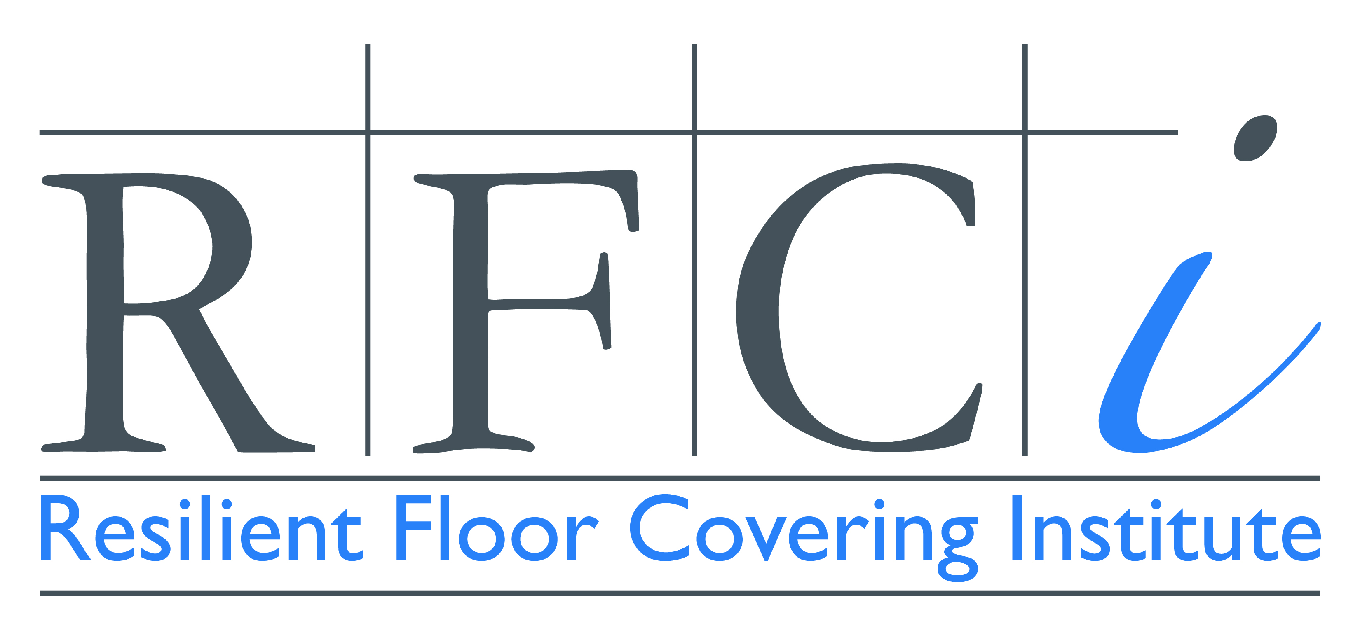

Resilient Flooring Industry Introduces Product Transparency Declarations
PTDs are Latest in Suite of Sustainability Tools

LaGrange, GA (October 10, 2013) The Resilient Floor Covering Institute (RFCI) announced today the availability of Product Transparency Declarations (PTDs) as a tool for disclosing product ingredients and performing a health risk assessment on finished flooring materials. PTDs address the informational needs of architects, designers and specifiers by disclosing intentionally added ingredients including heavy metals, acknowledging ingredients on six authoritative lists, and indicating whether the ingredient level triggers an exposure warning notification based on content in the building material or product. The six lists referenced in a PTD include the International Agency on the Research of Cancer Terminology, National Toxicology Program, the Occupational Safety and Health Administration, California Proposition 65, Environmental Protection Agency’s Toxic Release Inventory and REACH Substances of Very High Concern. PTDs go a step beyond Health Product Declarations in that they indicate whether there is a concern over human exposure to a product ingredient in a building material that requires a warning label.

The PTD concept was developed by RFCI to meet the needs of the specifier community for resilient flooring but PTDs can used be for all types of building materials. PTDs are published voluntarily by product manufacturers and are verified with the signature of a responsible company official. They are the latest in a suite of sustainability tools available for resilient flooring. Industry Average Environmental Product Declarations were recently introduced in August. The resilient industry also offers the NSF/ANSI 332 Sustainability Assessment Standard for Resilient Flooring, a third-party certified multi-attribute standard, and FloorScore®, a third-party certification by Scientific Certification Systems for indoor air emissions.

PTDs represent a step forward in marrying ingredient disclosure with exposure disclosure.
In addition to listing product ingredients, exposure risks and requirements for warning labels, PTDs identify if a heavy metal is an added ingredient and disclose recycled content, environmental certifications, VOC emissions and content, and whether the product complies with VOC emissions testing such as CA 1350.

“We are proud to be the first industry to offer Product Transparency Declarations,” said Dean Thompson, president of the Resilient Floor Covering Institute. “The resilient flooring industry has been diligent in its efforts to bring transparency to the sustainability process. PTDs are one of a variety of tools that assist specifiers and purchasers in evaluating and comparing the sustainability attributes of resilient flooring products.”

For more information on Product Transparency Declarations, visit www.rfci.com or call (706) 882-3833.

About RFCI
The Resilient Floor Covering Institute (www.rfci.com) is a LaGrange, GA-based nonprofit industry trade association that represents the major manufacturers of resilient flooring and materials used in resilient flooring marketed throughout North America. RFCI has helped the resilient flooring industry stay at the forefront of sustainability, leading the development of four environmental tools for purchasers and specifiers: the third-party multi-attribute ANSI/NSF 332 Sustainability Assessment for Resilient Floor Coverings; industry-average Environmental Product Declaration that disclose environmental impacts over a product’s lifecycle; Product Transparency Declarations that identify any harmful chemical ingredients and exposure levels associated with use; and the FloorScore® independent certification program for indoor air emissions.

